BPP Coursework Cover Sheet
Programme | MSc Management
Module name | Strategic Innovation and Entrepreneurship
Student Reference Number (SRN)
Report/Assignment Title | RenewWaste: A Digital, Incentivised Recycling Platform for Urban Households and SMEs in Lagos, Nigeria
Date of Submission
(Please attach the confirmation of any extension received.)
Declaration of Original Work:
- I hereby declare that I have read and understood BPP’s regulations on plagiarism and that this is my original work, and that I have researched, undertaken, completed and submitted in accordance with the requirements of BPP School of Business.

- I declare that where I have used any AI tools, it was for the following reasons (highlight as appropriate):
  - To review a draft
  - To correct language errors
  - Other (please describe)
_______________________________________________________
- I have copied & retained for BPP University’s reference all AI prompts used in the creation of AI content and all AI-generated responses in support of my assignment and attached relevant evidence in the appendices.

- I understand that I may be required to participate in a viva voce, where I will be questioned on any aspect of my assignment, including key concepts, theories, examples used, & any sources included.

- The word count, excluding contents table, bibliography and appendices, is ___ words.
Student Reference Number: Date:
By submitting this coursework, you agree to all the rules and regulations of BPP regarding assessments and awards for programmes. Please note that submission is your declaration that you are fit to sit.
BPP University reserves the right to use all submitted work for educational purposes and may request that work be published for a wider audience.
BPP School of Business

MSc Management

Strategic Innovation and Entrepreneurship
Word count: 3485 Excluding the tables

Table of Contents
Section 1: Personal Purpose and Entrepreneurial Motivation 5
Section 2: Market Opportunity and Value Proposition 6
2.1 Market Opportunity 6
2.2 Value Proposition 8
Section 3: Business Model and Strategy 9
Section 4: Financing Strategy 10
Section 5: Route to Market 12
Section 6: Sustainability and Ethics 13
Section 7: Launch Plan 14
Section 8: Reflection 15
Reference list 17
Appendices 21
Appendix: Capstone pitch 21

List of Figures
Figure 1: Value Proposition Canvas Summary 8
Figure 2:Business Model Canvas Summary 10

List of Tables
Table 1: Market Opportunity 7
Table 2: Estimated Costs (First 6 Months) 11
Table 3: Estimated Revenue (First 6 Months) 11
Table 4: Financial Position (First 6 Months) 11
Table 5: Key milestones with specific dates 15
Table 6: Core resources required 15

Overview - Summary of business idea and purpose of the report
The business concept involves a digitalised and incentivised recycling system for middle-income groups and SMEs in the city of Lagos, a context in which municipal solid waste management is a major problem. Lagos generates between 13,000 and 15,000 metric tons of waste daily, although the infrastructure for formal waste management is still underdeveloped, and public participation is low (Opanuga, 2025). Although the platform contributes to awareness of sustainability concerns and the need for waste recovery efficiency, it also has the potential to be too simplistic and to overlook structural issues such as low trust in digital systems, inconsistent infrastructure, and the dominance of informal waste collectors. Furthermore, study results have shown that environmental awareness is not necessarily enough to drive sustainable waste behaviour in developing countries. Therefore, the venture shows environmental and commercial promise, but if it is to be viable, the behavioural, technical, and operational realities must be integrated. This report analyses the venture's feasibility and its strategic sustainability.

Section 1: Personal Purpose and Entrepreneurial Motivation
Using Sinek's Golden Circle model, the 'why' is to tackle the problem of chronic waste management failures in Lagos, the 'how' is a digital and incentivised recycling programme, and the 'what' is the establishment of formal waste collection services for middle-income groups and SMEs. The purpose is personally relevant as the exposure to inadequate waste disposal practices and the sight of environmental degradation in Lagos is identified by the waste collection system, and the absence of participation of the population in recycling programs. Therefore, the project embodies both a professional interest in sustainable urban development and a personal drive to make a difference in more efficient environmental practices. However, while the Sinek model illuminates an organisation's intent, it is attacked for failing to recognise that purpose is not enough to lead to adoption and commercial success. Practically, the combination of infrastructural deficiencies and lack of trust in formal systems can affect the link between purpose and behaviour change.
It is more apparent when viewed from entrepreneurial motivation theories. Push-Pull theory proposes that entrepreneurial activity occurs when there is an opportunity recognition as well as contextual pressures. In this scenario, the venture is driven by pull factors (perceived gap in recycling service) and push factors (institutional inefficiency, bad municipal waste practices in Lagos) (Etim, 2024). Although this hybrid motivation creates more context relevance, Glinik et al. (2024) state that socially motivated ventures tend to face a challenge combining environmental goals with commercial viability. Consequently, although the business is mission-oriented, its sustainability relies on the ability to create financial profitability from customer demand, which stems from the value of the environment.
Additionally, entrepreneurial skills are needed, other than motivation alone. Drencheva et al. (2022) attribute entrepreneurial dimensions (opportunity recognition, resource mobilisation, resilience, and strategic networking) to critical factors for the success of a venture. Opportunity recognition is also relevant because the business sees an opportunity in the waste systems in Lagos, not being efficient. This is, however, an assumption that informal waste collectors are not dominant and that market gaps are easily exploitable. Likewise, resource mobilisation is a key to partnering, technology, and funding, but financial and institutional support is still limited in emerging economies. Therefore, while these skills enhance the concept of a business, they are constrained by environmental circumstances in terms of implementation.
However, the venture highlights the link between personal purpose, entrepreneurial motivation and sustainability-based innovations. However, the impact of these factors requires them to coincide with the realities of operations, customers, and institutions. If it is not aligned, the embedding of purpose and entrepreneurial skills remains an ambition instead of being commercially viable.

Section 2: Market Opportunity and Value Proposition

2.1 Market Opportunity
The Waste Management sector is a large market segment with structural limitations in Lagos. In Lagos, waste generation rate ranges between 13,000 and 15,000 metric tons; however, a small percentage of recyclable waste is collected through the formal waste management system (Etim et al., 2024). While this represents considerable unexploited potential, Musakabantu et al. (2026) suggest that the volume of waste doesn't create a sustainable market without effective waste recovery methods and user engagement. Thus, the opportunity is not only related to the availability of waste, but also to the levels of infrastructural and behavioural inefficiencies that need to be addressed.
Table 1: Market Opportunity
Segmentation Type | Target audience
Demographic | Middle-income households (150k-500k (naira)/month), SME owners
Geographic | Ikeja, Yaba, Surulere, Lekki (Lagos mainland)
Psychographic | Environmentally aware, convenience-driven, tech-literate
Behavioural | Currently spend more than five thousand naira per month on waste disposal.
However, target market segmentation is still too generic and needs to be narrowed down. The term ‘middle-income households and SMEs' is poorly defined and is uninformative for strategy. A more critical segmentation points out various user profiles. The main segment for households is the time-constrained, dual-income, urban people, like those in Ikeja and Lekki, who waste based on convenience instead of environmental care. In the case of SMEs, the segment of concern refers to small-scale commercial operators that have regular waste streams that can be recycled, and where decisions are made based on cost-efficiency and service reliability. This sophisticated perspective contradicts common notions that green awareness and care are key drivers of adoption.
While Lagos has more than 3 million households and has a high density of SMEs (Bassey, 2025), the participation in recycling is low, with waste being disposed of primarily for convenience, with little sorting unless there is immediate value (Quartey et al., 2025). This indicates that the barriers for the adoption of sustainability are not only a lack of awareness but also behavioural inertia. Market entry also makes things difficult due to the presence of informal waste collectors who manage adaptive and community-integrated low-cost systems (Oh and Hettiarachchi, 2020). These actors are not only competitors but also legitimate and scalable players who are deeply involved. Roberts-Lombard and Jaiyeoba (2025) also state that trust and service reliability are more important than incentives or awareness in determining participation. Thus, commercial opportunity depends on changing behaviour, reliability and on integration with the existing formal and informal waste system, rather than technology alone.

2.2 Value Proposition
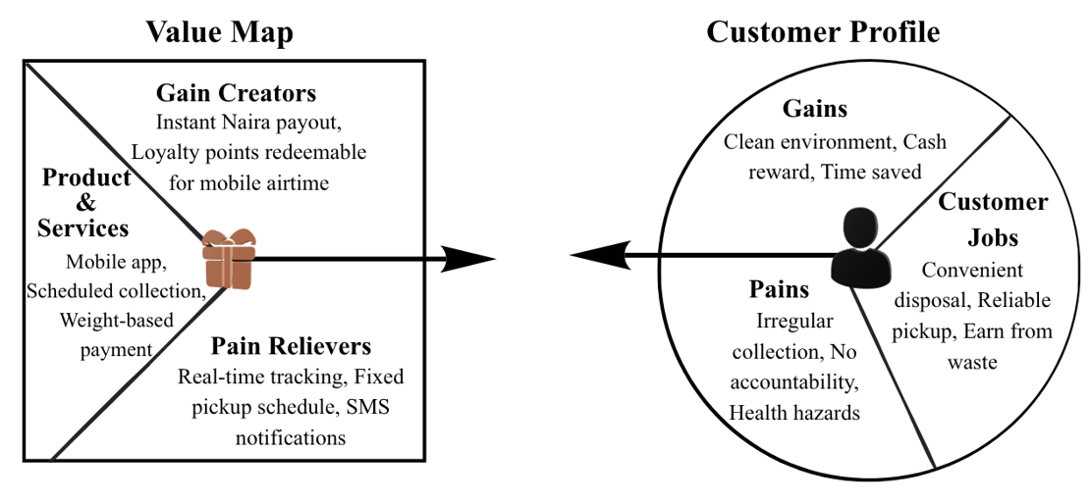
Figure 1: Value Proposition Canvas Summary
The proposed value proposition aims to solve the problem of inefficient waste disposal by implementing a digital, incentivised recycling platform. It is, however, largely based on the assumption that customer realities align with those captured in the Value Proposition Canvas (VPC) (Osterwalder et al., 2014). From the customer's point of view, important “jobs” would be ease of disposal, reliability of pick-up services and cost-effectiveness, while main “pains” would be inconsistent service, health impact from pollution and lack of accountability (Eshete et al., 2023). While the platform reacts to these by programmed collections and rewards, the literature that currently exists shows that such functional solutions are not enough to generate value in emerging market contexts.
The Value Proposition Canvas (VPC) has one major drawback: it assumes that customers act rationally and are interested in better services, but this assumption has not yet been thoroughly empirically tested. The ease of participation, habit and trust are more important than a value proposition in Lagos. In contrast, Faiz et al. (2024) find that operational trust and reliability factors have a more significant role in adoption than digital sophistication, underscoring a potential value proposition challenge of the platform. Incentives and digital features are not regular if collections are irregular. Furthermore, Asih et al. (2026) demonstrate that financial incentives alone are not sufficient to promote long-term recycling in an urban context. This is further complicated by informal waste collectors who provide reliable, flexible and cheap services (Simpson et al., 2024). The value proposition should, therefore, encompass incentives and functionality as well as trust building, behavioural reinforcement and connection to existing informal systems to enable successful adoption.

Section 3: Business Model and Strategy
The recycled business could be seen as a mixed social-commercial model in the dense waste management system of the Lagos region. The model aims to create revenue from material recovery and recycling, subscriptions and partnerships, as well as providing environmental and social value. However, hybrid models have an inherent strategic tension - seeking social impact can come at a price to financial sustainability, especially in markets where price sensitivity and infrastructure constraints are a problem (Nair, 2022). Therefore, while the enterprise shows a commitment to sustainability, the long-term sustainability of the company is dependent on the ability to create a sustainable commercial future from the environmental value.
One important caution in this model is that it does not provide enough clarity around social and commercial objectives being balanced in practice. This balance is not an easy thing to achieve and relies on efficiency of logistics, cost and revenue optimisation. In this context, informal waste collectors' associations play a crucial role. These actors already have networks for collecting, trust at the local level, and are flexible in operation. Their integration as commissioned agents or micro-entrepreneurs in the platform can lead to a cost reduction, greater accessibility of service, greater trust of users, and a combination of social inclusion and commercial efficiency. If that is not done, there's a danger of duplication of infrastructure and opposition from established informal systems.
Moreover, the business cannot be defined as a disruptive venture. Informal waste systems in Lagos are already efficient in their context, providing low-cost, adaptive waste services. Therefore, the business can be viewed as a “reconfigurative” innovation, which formalises and coordinates existing activities, rather than replacing them. This distinction is important because it can help avoid unrealistic scaling assumptions and strategic misalignment due to an overestimation of disruption potential.
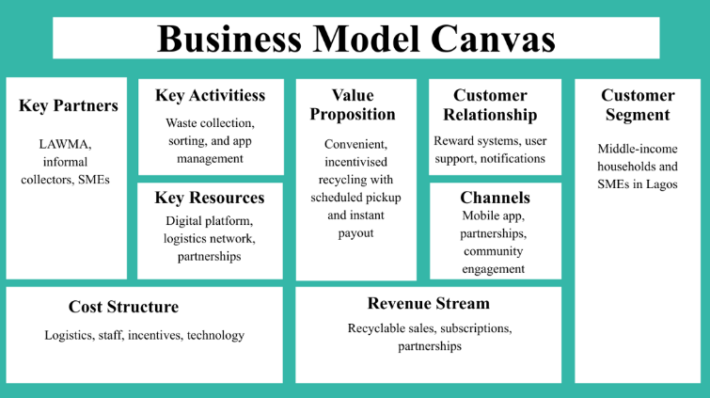
The Business Model Canvas (BMC) (Osterwalder and Pigneur, 2010) was adopted to organise value creation by the stakeholders, demonstrating the need for partnership, logistics, incentives and operational cost dependencies. The sustainability of the model, however, depends on learning from the actual circular economy initiatives, where success is associated with diversified revenue streams, operational efficiency and the extent of support from stakeholders. The BMC provides the strategic clarity, but as a fixed structure, it cannot fully represent the nature of behaviour change, informal competition, and infrastructural instability in the city of Lagos. The business should be seen as a learning system that is continually tested, learned and adapted to maximise social impact, while at the same time, being commercially sustainable.

Figure 2: Business Model Canvas Summary

Section 4: Financing Strategy
A realistic financing approach should be built around clear costs and revenue estimates and not on rosy forecasts. Table 1 shows that staffing, logistics, and incentives are the top three costs of the venture, highlighting the operational intensity of waste collection systems in Lagos.
Table 2: Estimated Costs (First 6 Months)
Cost Type | Item | Monthly Cost (₦) | 6-Month Total (₦)
Fixed Costs | App development | 300,000 | 1,800,000
 | Staff salaries | 400,000 | 2,400,000
 | Office/Admin | 100,000 | 600,000
Variable Costs | Logistics | 250,000 | 1,500,000
 | Marketing | 150,000 | 900,000
 | User incentives | 200,000 | 1,200,000
Total Costs |  | 1,400,000 | 8,400,000
The overall cost of 8,400,000 naira for 6 months demonstrates the enormous resource cost and the efficiency of the model in operation.
These expenditures must be compared with the value of revenue. Table 3 shows the revenue projections derived from the SME subscriptions, recyclables and strategic partnerships.
Table 3: Estimated Revenue (First 6 Months)
Revenue Stream | Monthly (₦) | 6-Month Total (₦)
SME subscriptions | 500,000 | 3,000,000
Recyclable sales | 400,000 | 2,400,000
NGO/brand partnerships | 300,000 | 1,800,000
Total Revenue | 1,200,000 | 7,200,000
While diversified, total revenue still falls short of total costs, and as a result, the outcome is negative, as demonstrated in Table 4.
Table 4: Financial Position (First 6 Months)
Metric | Value (₦)
Total Costs | 8,400,000
Total Revenue | 7,200,000
Net Position | -1,200,000
The predicted losses are typical for any business, but they provide a good example of how vulnerable the business model is. The absence of contingency planning is one of the biggest challenges, as the forecasts are made under the assumption of stable customer growth and operational stability. Practically, losses may be substantial due to delays in adoption or logistics issues. To minimise this risk, the enterprise should scale up when there is demand, and try to scale down fixed overheads by having flexible staffing and/or operating in the right areas with high population. Break-even is expected within a 9–12-month period, but this seems optimistic without a backup plan. In the case of a shortfall in revenue, the company might be forced to cut incentives, adjust pricing, or invest in more profitable partnerships. While bootstrapping and grants are valuable sources of early-stage funding, over-grant funding leads to strategic uncertainty and poor market alignment. Hence, a multi-faceted financing approach using impact investors, crowdfunding and blended finance is needed to enhance long-term financial sustainability and financial resilience.

Section 5: Route to Market
To critically assess the route-to-market strategy, a direct-to-consumer (D2C) and partnership-based approach needs to be benchmarked in terms of cost, scalability and behavioural alignment. D2C models benefit customers by providing better access to their information, and they benefit managers by increasing their managerial aspects over service quality, communication, and decision-making, which can improve service responsiveness over time (Kalayci et al., 2024). However, it is not without a price. For Waste2Wallet, a D2C approach would demand significant up-front investment in customer acquisition, logistics, and trust-building, a time when funds are scarce.
On the other hand, Partnership-based routes help lower entry barriers through using existing networks like local waste collectors, SMEs, and community groups. In emerging markets, intermediaries can also reduce the transaction costs and facilitate market entry since they already know and operate in the local environment (Rahman et al., 2023). This is especially relevant in the city of Lagos, where the informal waste collection services are already available and provide low-cost services. Therefore, Partnerships can be a fast path to entry, but can also result in loss of control over service quality, customer service and brand consistency.
Channel conflict is one of the other strategic issues. There can be overlapping responsibilities both directly and indirectly, which may affect efficiency, and issues with the ownership of the customers can arise (Pang and Yang, 2024). This is more than just a business issue. If the customer is the one to proactively contact the collector rather than Waste2Wallet, the value may be the value of the collector and not Waste2Wallet. If this is the case, the firm can deal without creating clients' loyalty. However, prematurely scaling up the D2C channel could lead to financial risk if demand turns out to be lower than anticipated.
Practical experience proves that single-channel strategies are less effective in fragmented markets and that hybrid strategies offer more scalability and market access, while maintaining control and flexibility (Zhang et al., 2023). Hence, D2C and partnerships should not work in isolation. Collaborations with local collectors and SMEs (in Ikeja and Yaba) can lead to lower launch costs and faster adoption rates, but can also challenge customer ownership. On the other hand, D2C channels provide greater brand control and customer relationships but have a high logistics, marketing, and customer trust investment requirement.
Hence, a hybrid approach is more defensible. Customer acquisition should focus on ease of access and value to the buyer, and not on environmental messaging. Social media content that portrays genuine Lagos households using the platform can further establish a sense of authenticity, while messages like “scheduled pickup, instant payout, no hassle” can have a greater impact in price-sensitive markets (Alenazi, 2025). Nevertheless, incentives are not the only way to retain. Balancing affordability, operational reliability, scalability, and behavioural habit formation depends upon consistent service delivery and rewards over a long period of time.

Section 6: Sustainability and Ethics
Critical sustainability and ethics analysis must not remain symbolic alignment but go beyond “value creation.” Waste2Wallet is aligned with SDG 11 and SDG 12, which focus on making better urban waste systems and promoting responsible consumption. But alignment is not enough to make an impact. Adesua-Lincoln (2025) has emphasised that Nigeria's sustainability efforts often suffer from poor implementation and infrastructure barriers. Therefore, the sustainability of the model is not the question, but whether it can deliver measurable results within the local context of operations.
Environmentally, the platform can contribute to a more effective collection rate and a reduction in reliance on landfill, thus promoting the circular economy goals. According to Etim (2024), a good waste system can produce environmental and economic benefits. However, this implies that service availability automatically translates to behaviour change; this is not guaranteed. Studies in urban African settings reveal that despite awareness of environmental issues, recycling is not consistently enacted, and that convenience is a factor that undermines intention. Therefore, the main environmental metric that must be measured is not just waste diversion rate (kg recycled/kg collected), although this is still the most common environmental measure that correlates with GRI 306.
A second measure would reflect behaviourally sustainable. Waste2Wallet can measure repeat participation by the percentage of users who have picked up at least 2 or 3 times a month for 6 months. Retention rates, repeat booking rate, and drop-off rates would be good indicators of whether recycling is becoming a habit or a single-time reaction to incentives. If not integrated into the behaviour, environmental impact might be exaggerated because early signups do not necessarily mean that the environmental impacts are ongoing.
Ethically, the role of informal waste collectors needs to be examined more. In Lagos, these actors are not a marginal group but are deeply rooted as market actors, having networks of trust and livelihood dependency. Without them, no sustainable model will survive without facing social exclusion, resistance and duplication of already established systems. Anyanwu et al. (2025) suggest that promoting sustainable business models in developing economies does not need to be a replacement for informal actors, but a way to engage them.
Waste2Wallet should work in cooperation with informal collectors as collection agents, neighbourhood coordinators or micro-franchise partners rather than compete with them. This approach contributes to livelihood continuity and increases the accessibility of services and community legitimacy. In this way, a sustainable effect demands not only environmental outcomes, but the inclusion of all participants, the protection of existing economic agents and the evidence of the sustainability effect in the medium to long term.
Section 7: Launch Plan
Lean startup principles say that a critical launch plan should be based on validated learning, not scaling. The Minimum Viable Product (MVP) for Waste2Wallet is not just a mobile app for requesting collection and tracking incentives. The digital function is not enough to validate the value of an infrastructure-dependent sector without also testing its operational reliability (Laureti et al., 2024). Customers in Lagos are more likely to rely on the quality of the app than on the timeliness of pickups and consistency of rewards. Thus, the MVP should be tested from the very beginning with both the digital interface and logistics chain.
Figure 5: Key milestones with specific dates
Phase | Timeline | Success Metric
MVP development: app, payment integration, routing system, and collection workflow | Month 1 | Platform functional, and 90% of test pickups have been completed on schedule.
Controlled pilot across two Lagos mainland wards with 50 households | Month 2 | At least 70% of pickups were completed successfully, and 50% of users booked a second pickup.
Early growth phase with targeted SME onboarding | Month 3 | 100 active users and at least 60% repeat usage within four weeks
Expansion and strategic partnerships | Month 4 | Stable weekly operations with no major service disruptions and two active collection partners
A staged approach ensures a better platform for assessment. Registration is not a valid measure of a pilot's success. Operational consistency, repeated participation and service reliability are essential for success under real conditions.

Table 6: Core resources required
Resource Type | Specific Item | How Secured
Staff | 2 collection agents, 1 operations manager | Freelance contracts (months 1-3), employed from month 4
Technology | Flutterwave, Google Maps API, SMS fallback | Free tier for first month, paid tier for subsequent months
Suppliers | Weighing scales, collection bags, baling equipment | Leased from Lagos Recyclers’ Association
Scalability is not a requirement, but rather an option. If pickup rates are not reaching the target or if there is little repeat use, then expansion should be delayed until logistical issues can be resolved. The staged launch helps reduce the risk in the initial operation and shows that the tested model can be taken into the market as a long-term product as well. In real terms, this involves knowing where, how or why things are going wrong, missed pickups, inefficient routing, lack of communication with customers or lack of reward delivery and rectifying them before entering new markets. If these weaknesses are not addressed now, there is a risk that trust will be lost in the future and that adoption rates will drop.

Section 8: Reflection
This project changed my view of entrepreneurship from an ideation to a more evidence-based and adaptable, critical decision-making focus. Frameworks such as the Value Proposition Design (VPD) initially appeared to be highly attractive to describe customer needs and to structure value creation. Nevertheless, the implementation of the framework in the city of Lagos in the field of waste management identified some important constraints. The Value Proposition Canvas assumes that the customer behaviour is somewhat rational and stable, as the pains are being alleviated and the gains are being created via the service. In practice, however, the disposal of waste in Lagos is driven more by convenience, habit, trust and informal waste disposal systems than by sound value propositions. This demonstrated to customers that value is not something that can be manufactured or assumed, but something that can be continually and constantly validated through interaction with real people.
Likewise, the Business Model Generation began to shed light on income streams, cooperation and action. But in a very dynamic and informal waste system, the framework was not as effective. The Business Model Canvas represents business models as varying degrees of stability and structure, whereas the recycling environment in Lagos is continuously influenced by infrastructural issues, informal waste collectors, irregular logistics and changing customer involvement. As a result, I realised that business models in emerging markets can no longer be considered "plans" but must be seen as "evolving systems".
I also liked the idea of Lean startups that focused on learning and experimentation through iteration. However, the application highlighted that iteration speed becomes more difficult in a business that is logistics-partner-reliability constrained, such as an infrastructure business. Thus, the main lessons of this project are that a framework can play a significant role as an analytical tool, but it is not a solution. They work when they are relevant, continually tested, and can relate theory to practicality.

Reference list
Alenazi, S.A. (2025). Sustainability Awareness, Price Sensitivity, and Willingness to Pay for Eco-Friendly Packaging: A Discrete Choice and Valuation Study in the Saudi Retail Sector. Sustainability, [online] 17(16), pp.1–20. Available at: https://ideas.repec.org/a/gam/jsusta/v17y2025i16p7287-d1722983.html.
Anyanwu, L.E., Felix, O.O., Ejike, I.W., and Anyanwu, I.O. (2025). Community-based waste management strategies and their impact on urban sustainability through citizen participation and local government collaboration. World Journal of Advanced Research and Reviews, [online] 28(2), pp.1638–1650. https://doi.org/10.30574/wjarr.2025.28.2.3809.
Asih, A.M.S., Prasetyo, D.H., and Sopha, B.M. (2026). Household recycling behaviour and community-based waste management: An agent-based modelling of socioeconomic heterogeneity in urban Indonesia. Journal of Environmental Management, 399(0), p.128658. https://doi.org/10.1016/j.jenvman.2026.128658.
Bassey, J. (2025). Listen to: Lagos projects $1bn earnings from SMEs, trains 253 trade ambassadors. [online] Businessday NG. Available at: https://businessday.ng/news/article/lagos-projects-1bn-earning-from-smes-trains-253-trade-ambassadors/ [Accessed 7 May 2026].
Drencheva, A., Stephan, U., and Patterson, M.G. (2022). Whom to Ask for Feedback: Insights for Resource Mobilisation From Social Entrepreneurship. Business & Society, 0(0), p.000765032110574. https://doi.org/10.1177/00076503211057497.
Eshete, H., Desalegn, A., and Tigu, F. (2023). Knowledge, attitudes, and practices on household solid waste management and associated factors in Gelemso town, Ethiopia. PLOS ONE, 18(2), p.e0278181. https://doi.org/10.1371/journal.pone.0278181.
Etim, E. (2024). Bridging the gap: Transforming waste management awareness into action. Cleaner Waste Systems, [online] 9(0), p.100173. https://doi.org/10.1016/j.clwas.2024.100173.
Etim, E., Choedron, K.T., and Ajai, O. (2024). Municipal solid waste management in Lagos State: Expansion and diffusion of awareness. Waste Management, [online] 190(0), pp.261–272. https://doi.org/10.1016/j.wasman.2024.09.032.
Faiz, F., Le, V., and Masli, E.K. (2024). Determinants of digital technology adoption in innovative SMEs. Journal of Innovation & Knowledge, [online] 9(4), p.100610. https://doi.org/10.1016/j.jik.2024.100610.
Glinik, M., Holzmann, P. and Rauter, R. (2024). Tensions of sustainability in the establishment of new ventures and their managerial responses. Cleaner production letters, 0(0), pp.100062–100062. https://doi.org/10.1016/j.clpl.2024.100062.
Imoisi, A. and Okoro, E. (2025). Advancing Sustainable Finance in Nigeria: A Policy- Oriented Analysis of Challenges and Opportunities. International Journal of Advanced Studies of Economics and Public Sector Management, [online] 13(1), pp.354–371. https://doi.org/10.48028/iiprds/ijasepsm.v13.i1.20.
Kalayci, E., Becker, J.U. and Barrot, C. (2024). Understanding customers’ choice for digital D2C versus multi-brand operations. Journal of Retailing, [online] 100(2). https://doi.org/10.1016/j.jretai.2024.02.001.
Laureti, L., Costantiello, A., Anobile, F., Leogrande, A. and Magazzino, C. (2024). Waste Management and Innovation: Insights from Europe. Recycling, 9(5), pp.82–82. https://doi.org/10.3390/recycling9050082.
Musakabantu, A., Chibuye, B.J., and Like, C. (2026). Factors Influencing Solid Waste Management Practices: A Case of Masala Market, Ndola District, Zambia. International Journal of Research and Innovation in Social Science, [online] 10(3), pp.2864–2878. https://doi.org/10.47772/ijriss.2026.100300211.
Nair, P.B. (2022). Embracing Hybridity: A Business Model Innovation for Sustainable Social Enterprises. International Journal of Business and Society, 23(3), pp.1600–1617. https://doi.org/10.33736/ijbs.5186.2022.
Oh, J. and Hettiarachchi, H. (2020). Collective Action in Waste Management: A Comparative Study of Recycling and Recovery Initiatives from Brazil, Indonesia, and Nigeria Using the Institutional Analysis and Development Framework. Recycling, 5(1), p.4. https://doi.org/10.3390/recycling5010004.
Opanuga, J. (2025). Lagos generates 13,000 tonnes of waste daily - Official | The Guardian Nigeria News - Nigeria and World News. [online] The Guardian Nigeria News - Nigeria and World News. Available at: https://guardian.ng/news/nigeria/metro/lagos-generates-13000-tonnes-of-waste-daily-official/.
Osterwalder, A. and Pigneur, Y. (2010). Business Model Generation: A Handbook for Visionaries, Game Changers, and Challengers. Hoboken, New Jersey: John Wiley & Sons.
Osterwalder, A., Pigneur, Y., Bernarda, G. and Smith, A. (2014). Value Proposition Design: How to Create Products and Services Customers Want. Hoboken, New Jersey: John Wiley & Sons.
Pang, F. and Yang, Q. (2024). Channel diversity, constructive and destructive conflicts: the moderating role of network centrality. Journal of Business and Industrial Marketing, 39(11), pp.2438–2449. https://doi.org/10.1108/jbim-05-2023-0247.
Quartey, E.K., Nyamah, E.Y., and Charnor, I.T. (2025). Waste management practices and environmental sustainability performance: Does institutional pressure matter? Journal of responsible production and consumption, 0(0). https://doi.org/10.1108/jrpc-11-2024-0063.
Rahman, M.M., Rahman, M., and Masud, Md.A.K. (2023). Determinants of the Cost of Financial Intermediation: Evidence from Emerging Economies. International Journal of Financial Studies, 11(1), p.11. https://doi.org/10.3390/ijfs11010011.
Roberts-Lombard, M. and Jaiyeoba, O. (2025). Unlocking consumer behaviour: How satisfaction and/or delight, trust and perceived value drive behavioural intentions. South African Journal of Economic and Management Sciences, [online] 28(1), p.17. Available at: https://sajems.org/index.php/sajems/article/view/6160/3578.
Schoeman, D.C. and Rampedi, I.T. (2022). Drivers of Household Recycling Behaviour in the City of Johannesburg, South Africa. International Journal of Environmental Research and Public Health, 19(10), p.6229. https://doi.org/10.3390/ijerph19106229.
Simpson, M., Oduro-Appiah, K., Gunsilius, E., Dias, S.M., and Scheinberg, A. (2024). Shifting perceptions of informal operators in the service and value chains: A retrospective of 40 years of observation and advocacy for informal recyclers and waste service providers, through the eyes of five global participant-researchers. Waste Management & Research The Journal for a Sustainable Circular Economy, 0(0). https://doi.org/10.1177/0734242x241280076.
Zhang, Q., Liu, H., and Cai, Z. (2023). Hybrid channel structure and product quality distribution strategy for an online retail platform. PLOS ONE, 18(5), pp.e0285860–e0285860. https://doi.org/10.1371/journal.pone.0285860.

Appendices

Appendix: Capstone pitch
Slide 1: RenewWaste: A Digital, Incentivised Recycling Platform for Urban Households and SMEs in Lagos, Nigeria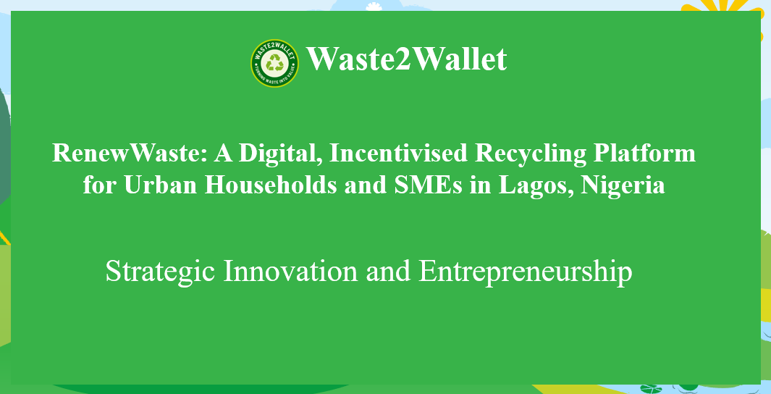

Slide 2 - Opening - The Pitch
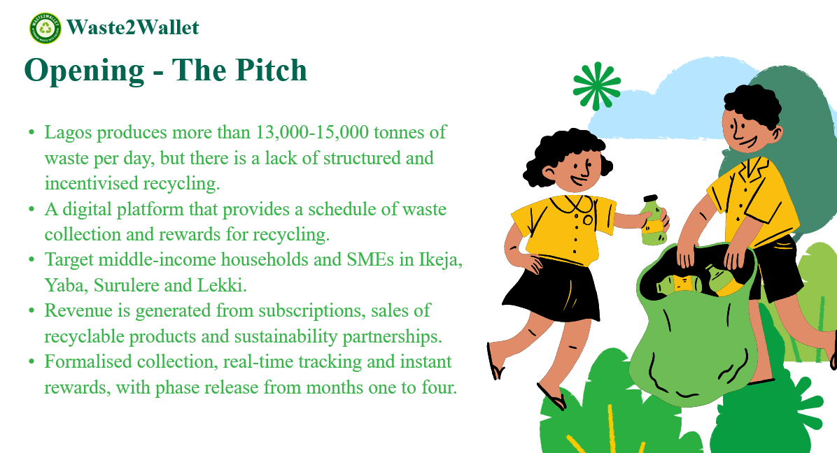
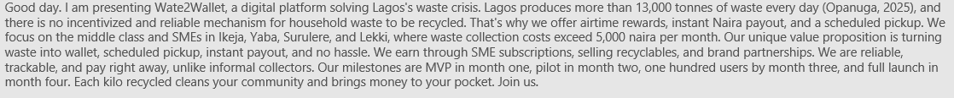

Slide 3 - Customer Jobs
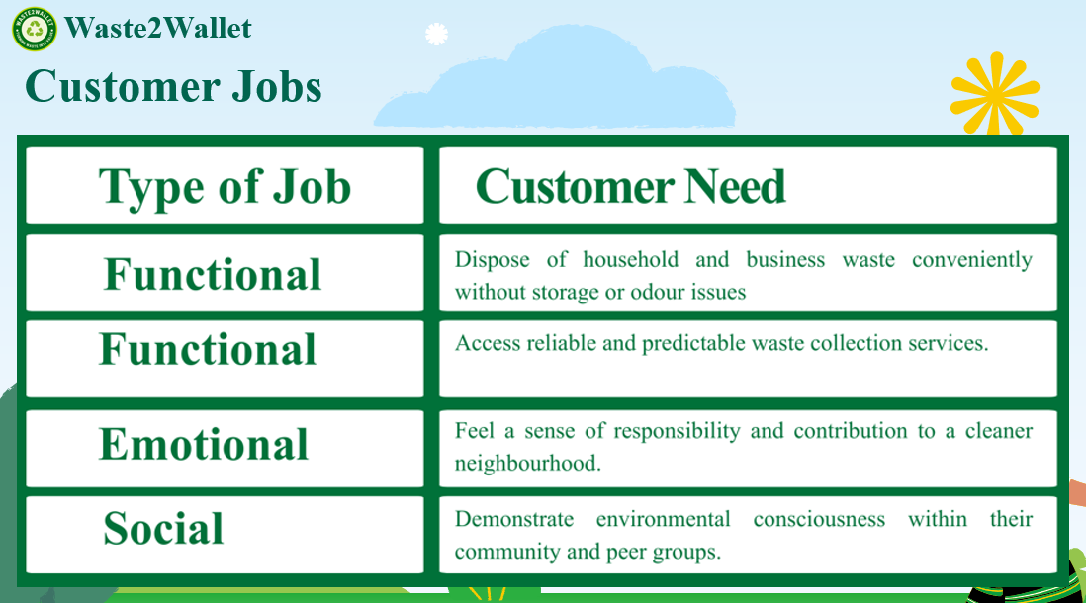
Slide 4 - Customer Pains
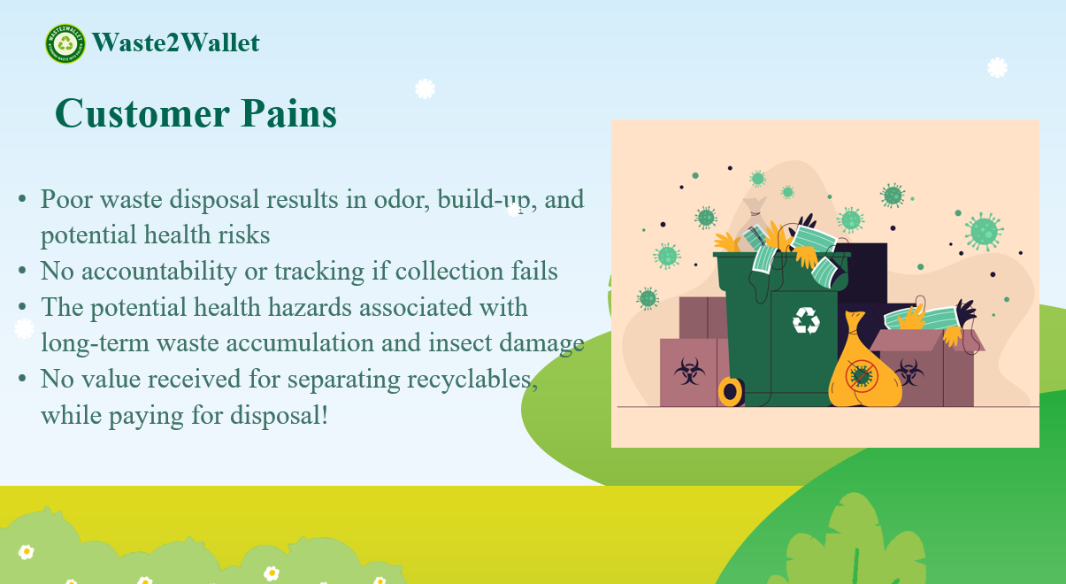
Slide 5 - Customer Gains
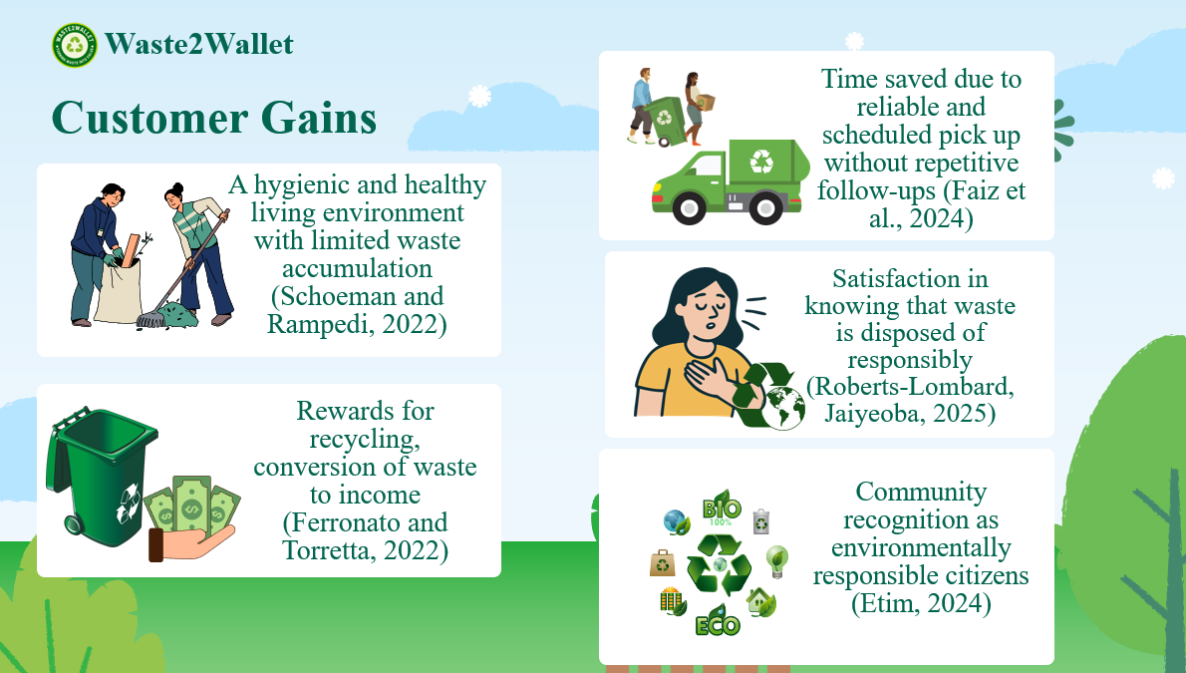
Slide 6 - Products and Services
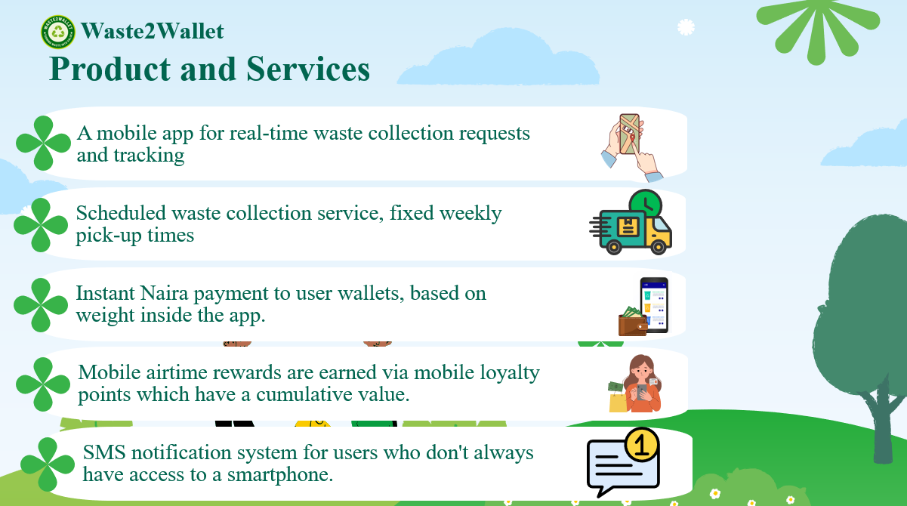

Slide 7 - Pain Relievers
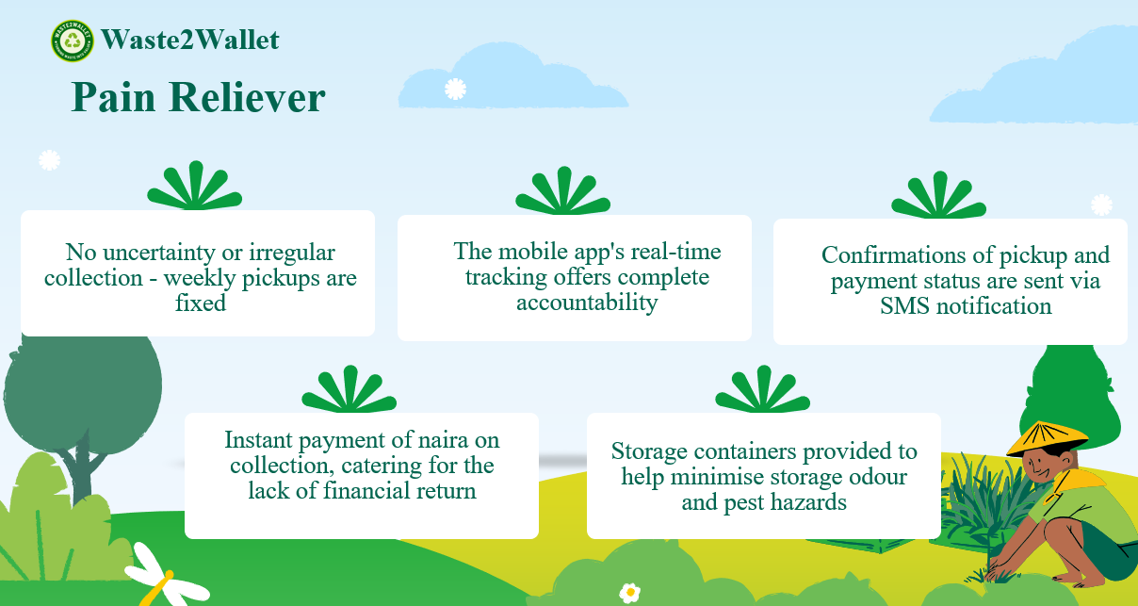

Slide 8 - Gain Creators
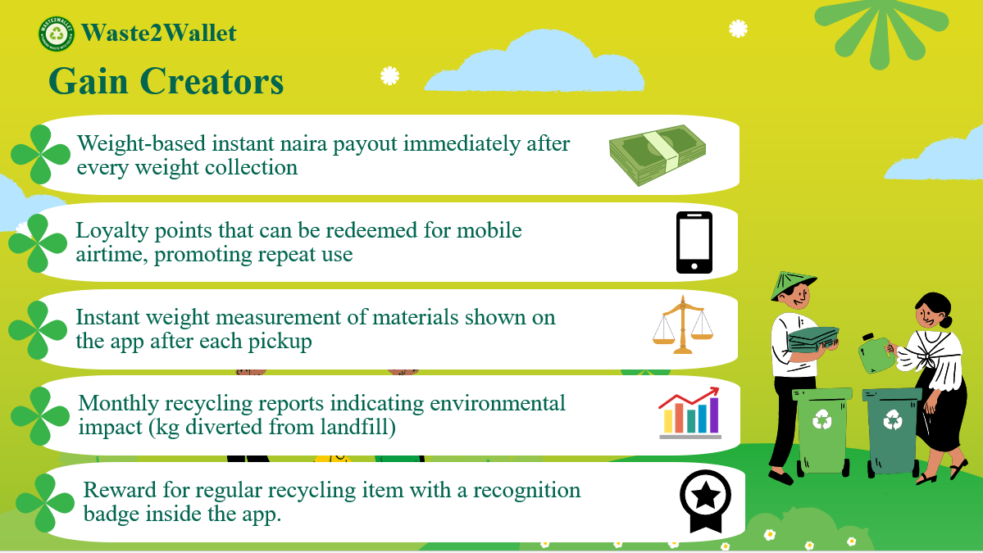

Slide 9 - Reflection and Learning
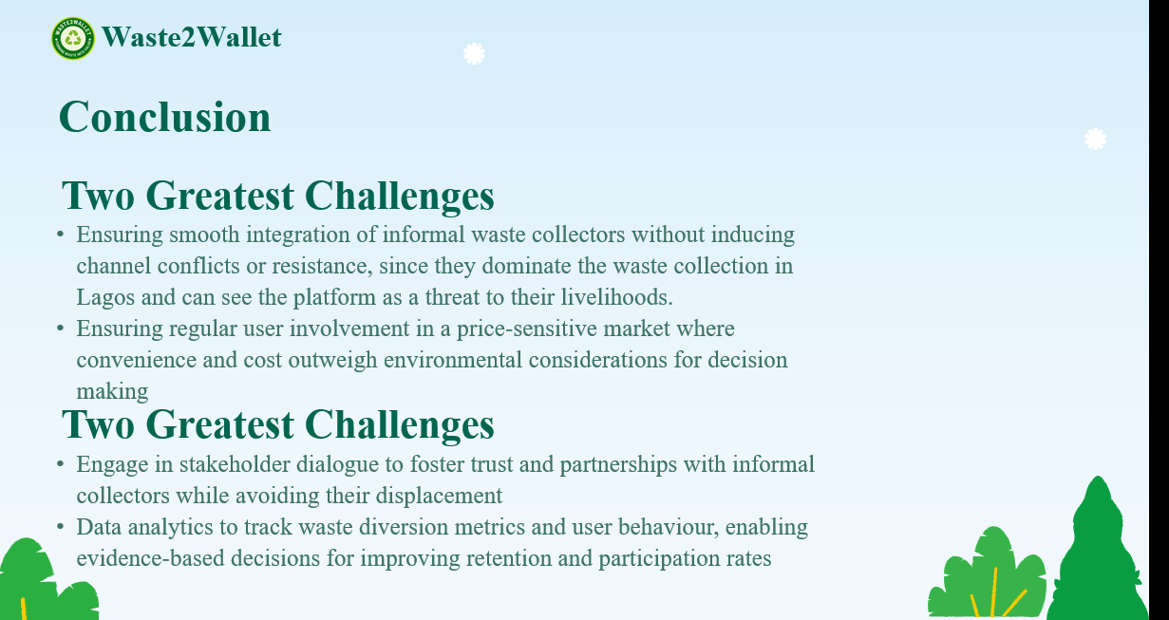
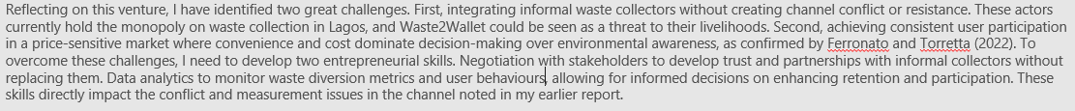

Slide 10 - References
